input.docinput.doc
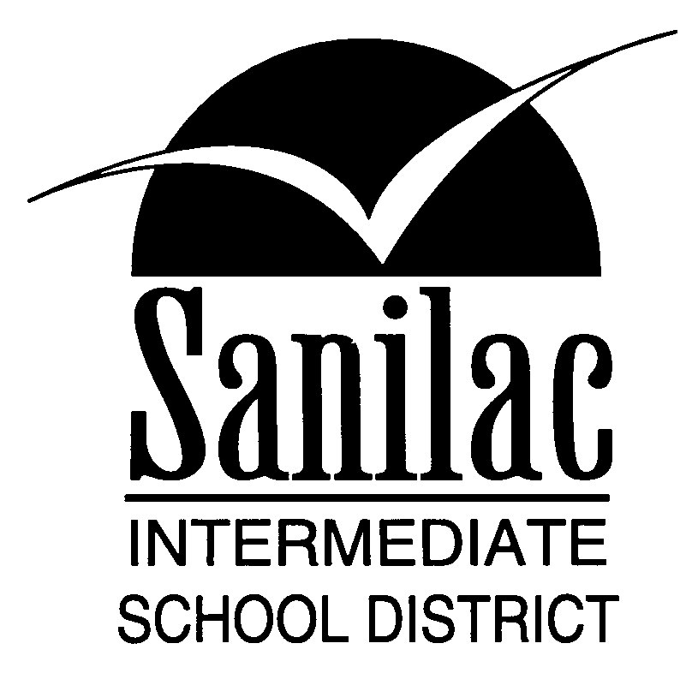
Special Education Services
46 North Jackson Street
Sandusky, Michigan 48471
810-648-2200

SANILAC INTERMEDIATE SCHOOL DITRICT AND
________________________ SCHOOL DISTRICT

OFFICE OF SPECIAL EDUCATION SERVICES

Notice of Proposal to Dismiss and to Discontinue Special Education Services
Due to Receipt of Written Withdrawal of Parental/Adult Student Consent
for the Continued Provision of Special Education Services
34 CFR §300.503, 300.9 & 300.300
18 TAC§89.1050

Student Name: ____________________________________________ Date: ___________________

Date of Birth: ___________________

Special education means specially designed instruction, at no cost to the parents, to meet the unique needs of a child with a disability. Eligibility for special education is determined on the basis of evaluations determining the need for specialized instruction in order for the student to benefit in a public school setting.

Along with the instruction, there are many rights and protections offered to special education students that are not available to students in general education. The purpose of this notice is to provide the parent/adult student with information to allow them to make an informed decision regarding their decision to withdraw consent for the continued provision of special education services to their child and to inform them of the implications of the decision to withdraw consent.

I understand that in withdrawing my consent for my child/myself to continue to receive special education carries with it the following implications (please initial each section):

________ I/My child will be dismissed from special education and will no longer receive any special education or related services.

________ I/My child will no longer be considered to have a disability.

________ I/My child will be educated in all general education classes and will not have the benefit of special education modifications, accommodations, specialized instruction or related services. All instruction will be provided on grade level and my child will be held to the same standards of accountability as any other non-disabled student.

________ I/My child will be held to the promotion/retention standards applicable to general education students.

________ I/My child will be required to meet all graduation requirements. If my child does not meet with all graduation requirement required of general education students, my child may not be able to graduate and receive a diploma through general education.

________ I/My child will be expected to follow the ________________School District Code of Student Conduct and will be subject to the same expectations and regular discipline consequences of non-disabled students. If, after dismissal from special education, the school district proposes to discipline my child in a manner that involves removal to a disciplinary alternative education program or expulsion and I decide to seek an evaluation to determine eligibility for special education, ______________ District and Sanilac Intermediate School District (SISD) will be deemed to have no knowledge of my child’s suspected disability and may implement the discipline pending a new evaluation to determine eligibility.

________ If I/my child have already received special education and related services, the District is not required to amend my/my child’s education records to remove any references to the receipt of special education and related services because of the revocation of consent.

________ I understand that the provision of any instructional and related services not completed as stated in any previous IEP report shall cease on the date of the signature of this form and will not be provided by the school district. This includes any compensatory services, services agreed as part of any Resolution Session, services agreed to as part of any settlement Agreement or mediation Agreement entered into with ______________ District and Sanilac Intermediate School District (SISD) and any services ordered by an impartial hearing officer as a result of any due process hearing that may have been filed.

________ I understand that my revocation of parental consent releases the ______________ District and Sanilac Intermediate School District (SISD) from liability for providing a Free and Appropriate Public Education to myself/my child from the time I revoke consent for special education and related services until the time, if any, that I/ my child is evaluated and deemed eligible, and I provide consent at that time for placement and for the provision of special education and related.

If you have questions regarding this Notice, you may contact your district Special Education Coordinator or the Special Education Services Administrative Office at Sanilac Intermediate School District (SISD)

Your signature below indicates that you understand the contents of this Notice of Proposal or Refusal and that, you understand the statements above and you are withdrawing your consent for the provision of special education and related services. Additionally, you fully understand the consequence of your withdrawal of consent and are in agreement with the termination of special education services effective on the date you sign this agreement. .

__________________________________________________ ___________
Parent/Adult Student Signature Date

__________________________________________________ ___________
Received by (Admin) Date

